**ONLINE BANKING SYSTEM**

Table Of Content

1. Introduction 4

**1.1 System Purpose** 4

**1.2 System Scope** 4

**1.2.1 Admin Module** 4

**1.2.2 Web Portal Module for Users** 5

**1.2.3 Universal Applicability** 5

**1.3 System Overview** 5

**1.3.1 Admin Module** 5

**1.3.2 User Module** 5

**1.4 Definitions** 6

**1.4.1 Actors:** 6

**1.4.2 Technologies to be used:** 6

2. Overall Description 7

**2.1 Product Perspective:** 7

**2.1.1 System Interfaces:** 7

**2.1.2 Hardware Interfaces** 7

**2.1.3 Software Interfaces** 8

**2.1.4 Communication Interfaces** 8

**2.1.5 Product Functions** 9

**2.1.6 User Characteristics** 9

3. Specific Requirements 10

**3.1 Design Constraints** 10

4. Design Diagram 11

**4.1 Context level Diagram:** 11

**4.2 Use Case Diagram:** 11

**4.3 UML Diagram:** 11

**4.4 Class Diagram:** 12

5. Modules 12

**5.1 Interface:** 12

**5.2 User and admin login module:** 13

**5.3 User Registration Module:** 13

**5.4 Account Registration Module:** 14

**5.5 Customer KYC Module:** 14

**5.6 Transition Entry Module:** 15

**5.7 Feedback Module:** 15

**5.8 All Banking Services And Future Scope:** 16

6. Conclusion 17

# 1. Introduction

## **1.1 System Purpose**

**The system's primary purpose is to facilitate convenient and secure financial transactions through internet-based services, commonly referred to as online banking or internet banking. It offers customers a comprehensive range of banking functions, including deposits, fund transfers, and online bill payments. Virtually all banking institutions provide online banking access, accessible through web browsers or mobile applications.**

**Key Points:**

* **Convenience: Online banking eliminates the need to visit a physical branch for routine banking transactions.**
* **Accessibility: Users can access their accounts and perform transactions from anywhere, whether at home, work, or on-the-go.**
* **Channels: Online banking is accessible via web browsers for desktop users and tablets.**
* **Security: Emphasis is placed on ensuring the security of all online transactions.**
* **Efficiency: Users can conduct their banking activities at their own convenience and without time constraints.**

**This revised version provides a more concise and focused description of the system's purpose, highlighting its core features and benefits.**

## **1.2 System Scope**

The functional scope of the system is encompassed by two key modules: the Admin Module and the Web Portal Module for Users.

### **1.2.1 Admin Module**

The Admin Module is dedicated to system administration and provides administrators with the following capabilities:

* User Management: Administrators can access and manage bank users' personal information, including account details.
* Account Operations: Administrators have the authority to perform various account operations, such as deleting bank accounts and initiating deposits to specific accounts.
* Transaction History: The module enables administrators to review the complete transaction history of the bank, ensuring transparency.
* User Registration: Admins can approve registration requests from new users and respond to inquiries and messages from bank users.

### **1.2.2 Web Portal Module for Users**

The Web Portal Module for Users caters to the needs of bank customers and offers the following features:

* Account Management: Registered users can request account-related operations, such as account creation, deletion, or modifications.
* Fund Transfers: Users have the capability to transfer funds between accounts, facilitating transactions with ease.
* Personal Information Editing: Users can update their personal information as needed.
* Transaction History: Access to transaction history empowers users to track their financial activities.
* Communication: The module allows users to send messages to administrators for assistance or inquiries.

### **1.2.3 Universal Applicability**

The online banking system is designed to be universally applicable, serving the banking needs of individuals and institutions across all regions where banking services are available. It offers a more efficient and accessible means of maintaining financial records, granting users the ability to access services based on their roles and permissions.

## **1.3 System Overview**

The system is structured around two core modules: the Admin Module and the User Module, each serving distinct functions within the system.

### **1.3.1 Admin Module**

The Admin Module is dedicated to system administration and provides administrators with comprehensive management capabilities, including:

* Administrative Control: This module empowers administrators to manage all aspects of the system required for efficient system administration and operation.

### **1.3.2 User Module**

The User Module is designed for customers and represents the user-facing component of the system. It offers a range of essential functionalities, allowing users to:

* Account Management: Users can access their accounts, view balances, perform balance transfers, and check transaction history.
* Financial Services: Customers have the ability to apply for various financial services, such as credit cards and different types of loans, including personal and home loans.

This modular structure ensures effective system management and provides customers with a user-friendly online banking experience. It streamlines administrative tasks while offering customers access to a wide array of financial services.

## **1.4 Definitions**

### **1.4.1 Actors:**

* Admin
* Customer

### **1.4.2 Technologies to be used:**

* Spring Boot
* Recat.js, Node.js
* MySQL
* Html, CSS
* Java script.

# 

# 2. Overall Description

## **2.1 Product Perspective:**

The system encompasses three distinct interfaces:

### **2.1.1 System Interfaces:**

* Hardware Interfaces: These interfaces define the system's connections and interactions with physical hardware components.
* Software Interfaces: These interfaces specify the interactions and integrations between the system and other software components or services.
* Communication Interfaces: These interfaces govern how the system communicates with external entities, including users and external systems.

This classification ensures a clear delineation of the system's interfaces, facilitating a comprehensive understanding of its interactions and connections.

### **2.1.2 Hardware Interfaces**

#### **2.1.2.1 Minimum Requirement:**

* Processor: Intel Core i3
* RAM: 4GB
* Hard Disk: 500GB
* Monitor: 15-inch colour monitor

These hardware specifications serve as the baseline configuration necessary to run the system effectively.

#### **2.1.2.2 Typical Hardware Interface Requirements:**

1. Server Hardware:

* Multi-core processor (e.g., Intel or Redon) for handling server-side logic.
* Sufficient RAM (e.g., 8GB or more) to handle concurrent user requests and database operations efficiently.
* Adequate storage space (e.g., SSD) for storing application files and database data.

1. Client Hardware:

* Any modern computer or tablet device with a web browser can access the application. Specific hardware requirements for clients are minimal.

1. Network Connectivity:

* Reliable internet connection for both server hosting and client access.
* Sufficient bandwidth to handle concurrent user connections and data transfer.

1. Database Server:

* If using a separate database server, it should meet the hardware requirements for the chosen database management system (e.g., MySQL, XAMPP).

1. Firewall and Security Hardware:

* Security hardware and software solutions to protect against cyber threats and data breaches.

### **2.1.3 Software Interfaces**

The system relies on several software interfaces for its functionality:

1. Server Communication: The system interacts with a server to facilitate user-admin interactions.
2. Database Management: Data within the system is managed by a Database Management System (DBMS).
3. Required Software Configuration:

* Spring Tool Suite 4: Integrated Development Environment (IDE) for software development.
* VS Code: Used for front end development
* Apache Tomcat: Web server and servlet container for hosting Java-based web applications.
* MySQL: A MySQL database used for data storage and retrieval.
* XAMPP: A web server solution stack (Apache, MySQL, PHP, and Perl) used for local development and testing.

These software components ensure the proper functioning of the online banking system, enabling development, hosting, and data management.

### **2.1.4 Communication Interfaces**

The system's communication interfaces are structured as follows:

* User Registration: User initiate the process through bank, providing necessary details including Aadhar card, PAN card, and a photo.
* Admin Approval: After document verification and approval by the admin, users gain access to the system's services.
* Service Requests: Registered users can request various services, including debit, credit, transfer and feedback through web portal.

### **2.1.5 Product Functions**

#### **2.1.5.1 Admin:**

* Admin Login: Access to the system requires administrator login credentials.
* Account Management: Admin can view, add, and delete bank accounts.
* Admin Module Access: Admin logs in using dedicated credentials for the admin module.
* User Management: Admin has the capability to add new users and associate them with accounts.
* KYC Approval: Admin can approve Know Your Customer (KYC) submissions and review user feedback.

#### **2.1.5.2 Customer:**

* User Login: Access to the system requires user login credentials.
* Benificiary: Adding beneficiary to transfer money
* Account Management: Users can view account balances, perform money transfers, and withdraw funds.
* Feedback: Giving feedback that will reflect directly to the admin and then admin can make changes according to that

### **2.1.6 User Characteristics**

The system caters to two primary user groups:

* Registered Customers: These are viewers who have previously interacted with the bank and have completed the for filling.
* Admin Users: All administrators will be using Windows desktops to conduct their administrative tasks within the system.
* Device Variety: The system is designed to accommodate a wide range of customer devices, including laptops and desktops running various operating systems, to ensure full website accessibility and usability for all customers.

# 3. Specific Requirements

## **3.1 Design Constraints**

The system will adhere to the following design constraints:

* Browser Compatibility: The system must function seamlessly on major internet browsers, including Internet Explorer, Firefox, Chrome, Safari, Opera, and Android browsers.
* Host Computer OS: The system will be constrained by the host computer's operating software, which is Windows. It must be compatible with Windows operating systems.

# 4. Design Diagram

## **4.1 Context level Diagram:**

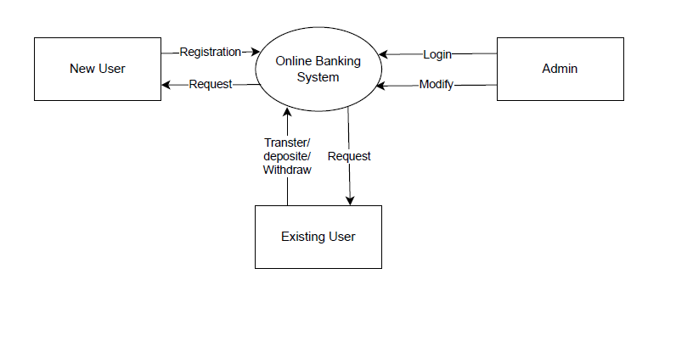

## **4.2 Use Case Diagram:**

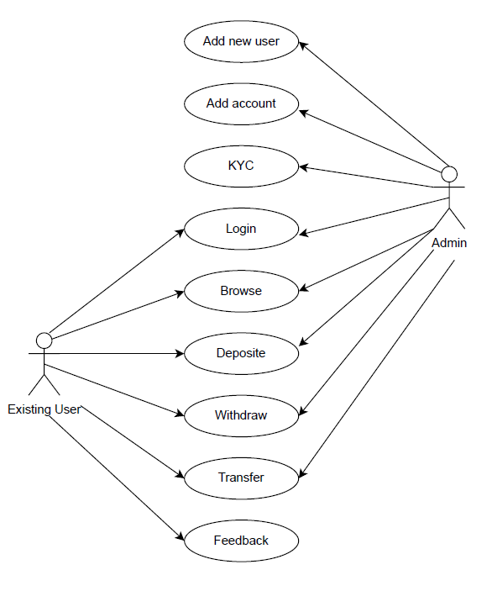

## **4.3 UML Diagram:**

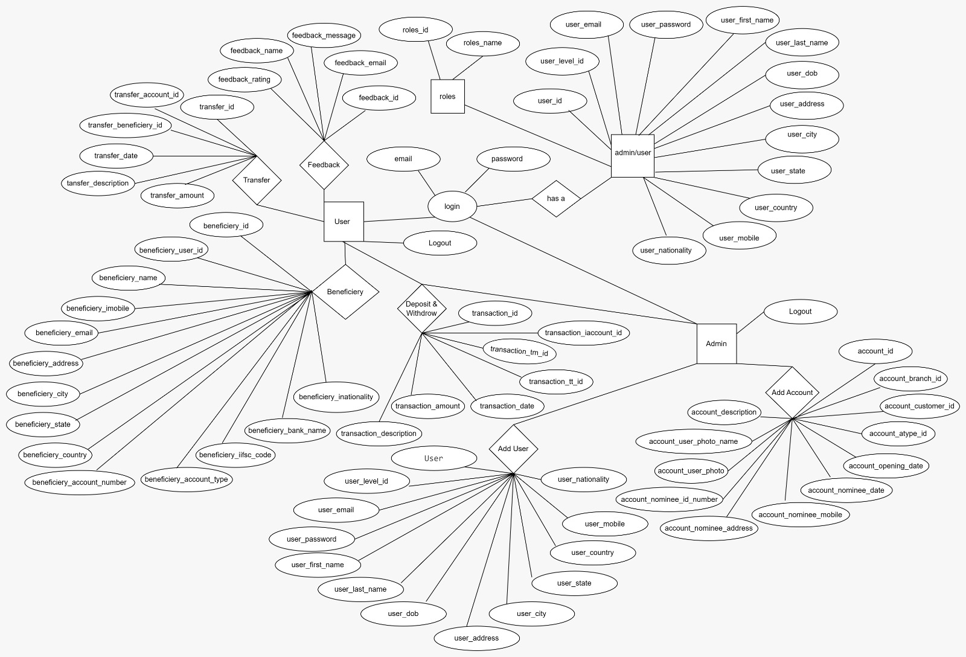

## **4.4 Class Diagram:**

# 5. Modules

## **5.1 Interface:**

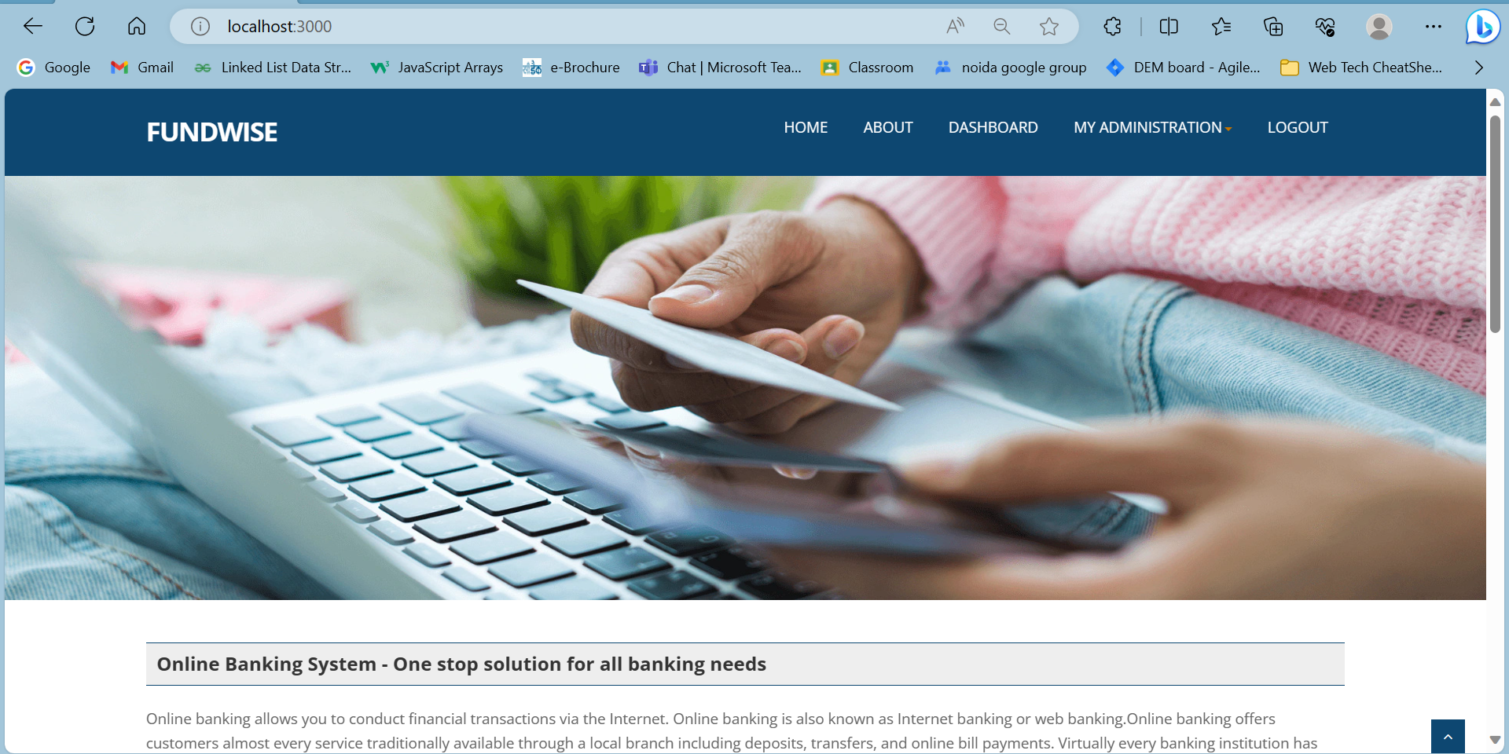

## **5.2 User and admin login module:**

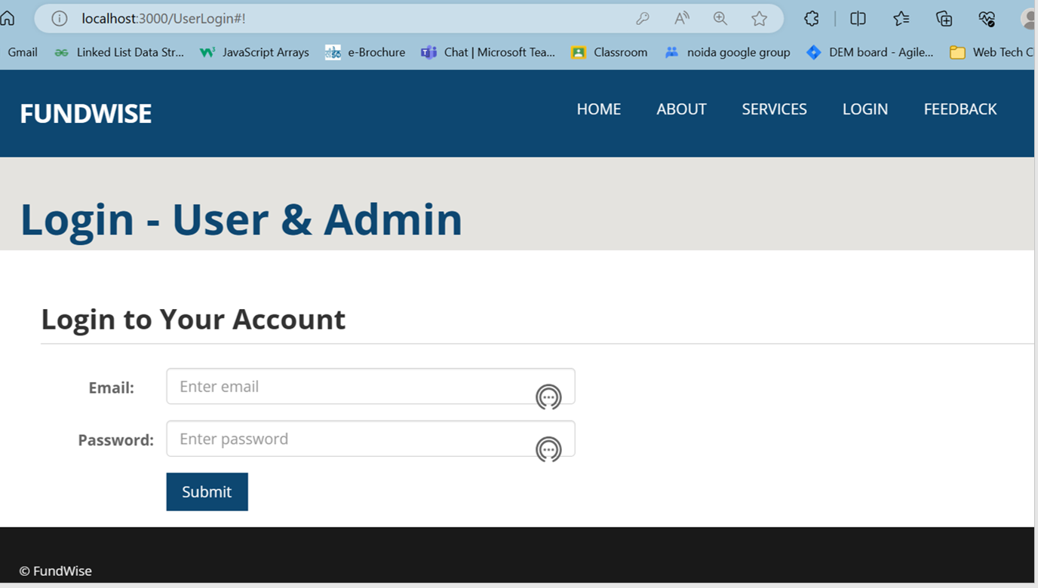

## **5.3 User Registration Module:**

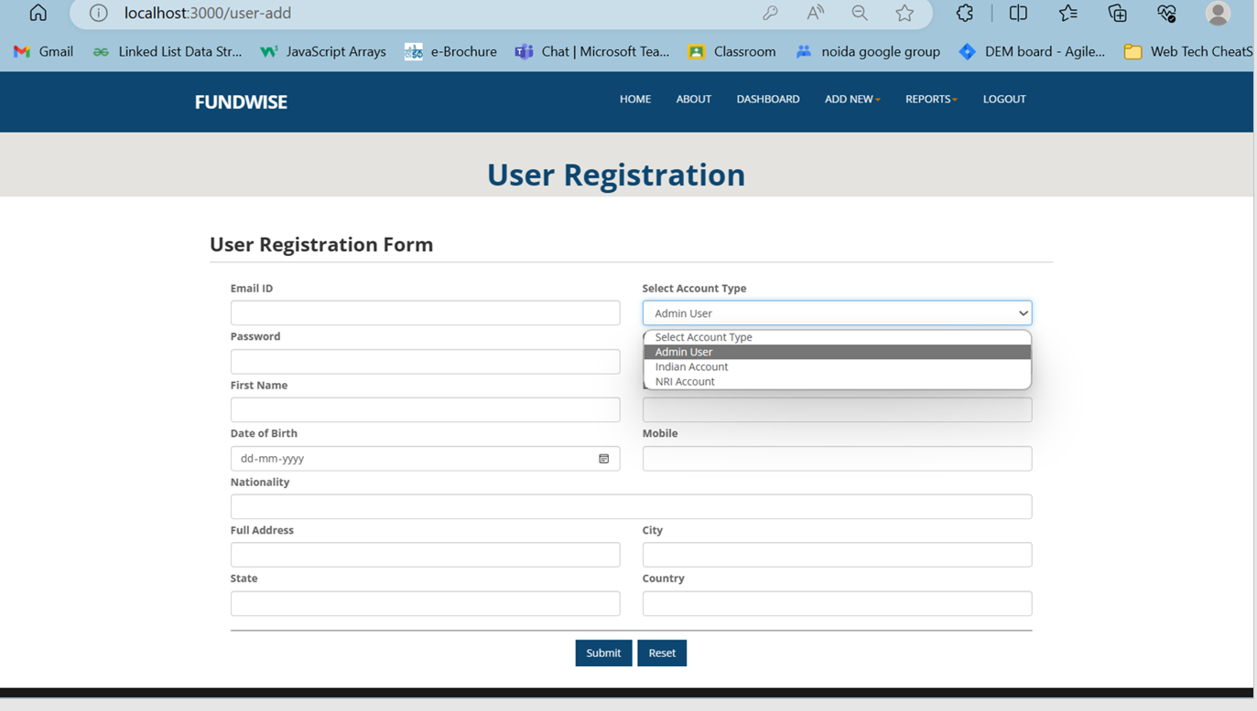

## **5.4 Account Registration Module:**

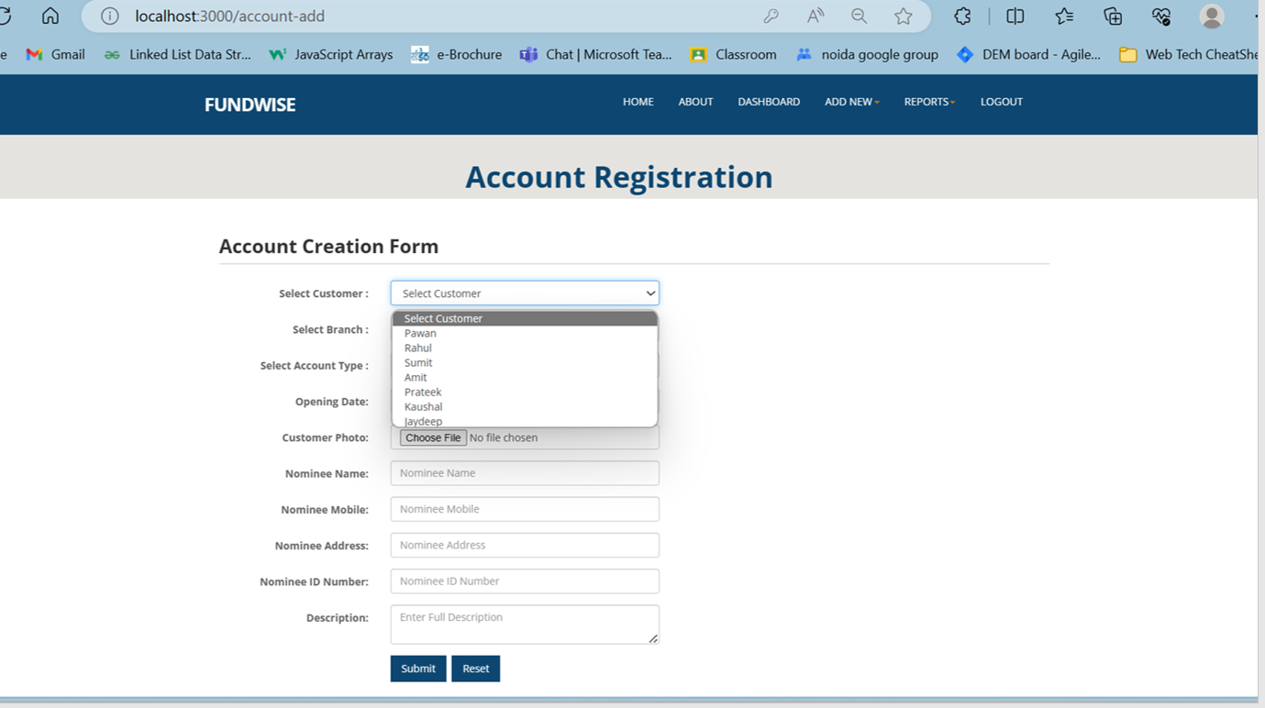

## **5.5 Customer KYC Module:**

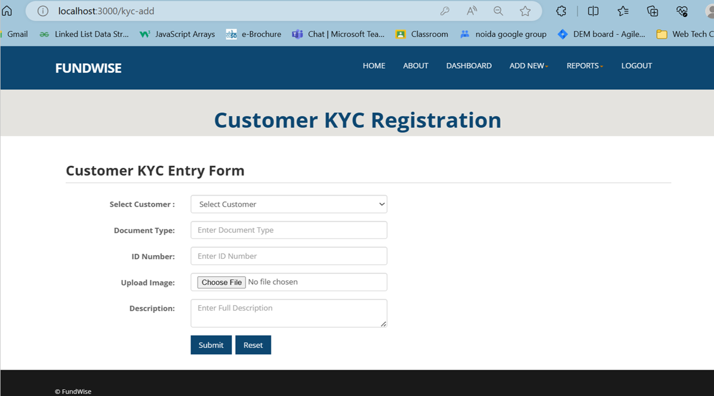

## **5.6 Transition Entry Module:**

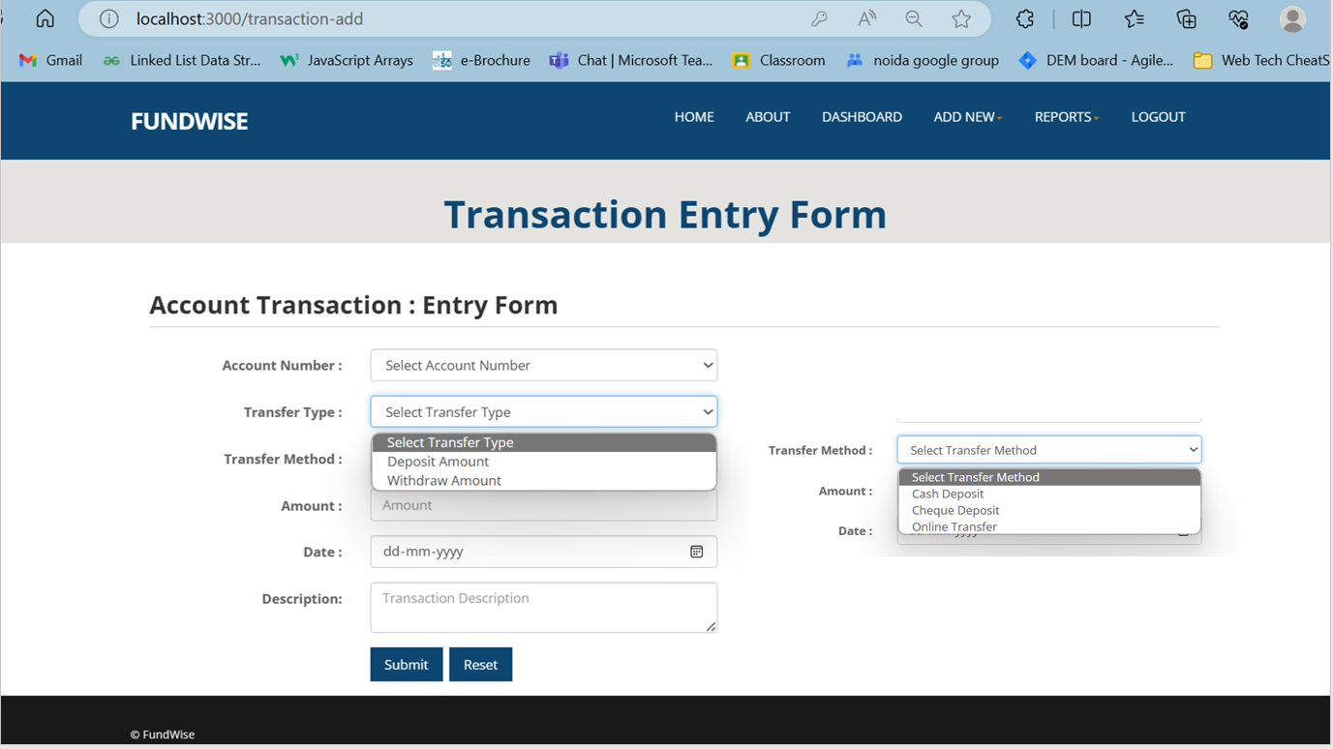

## **5.7 Feedback Module:**

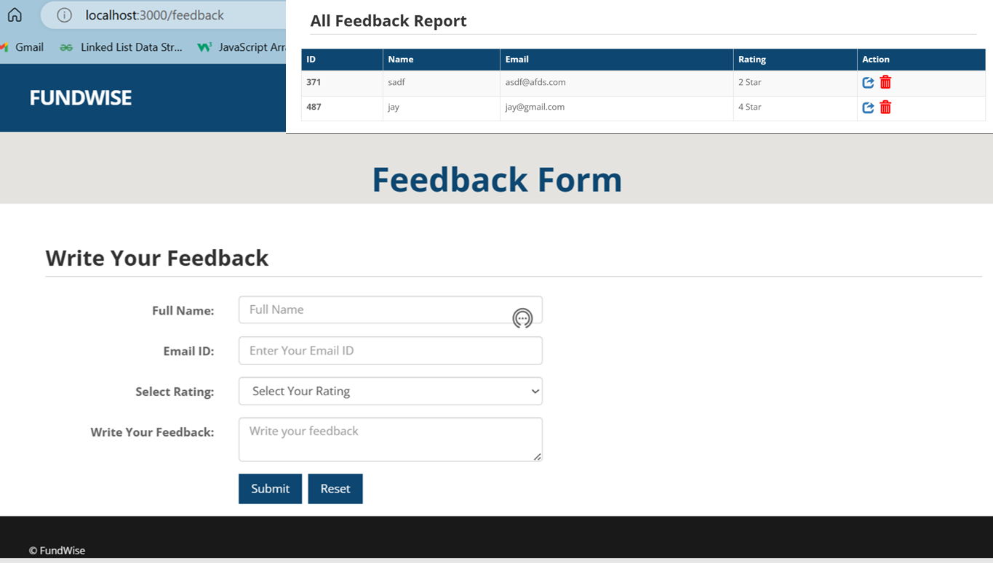

## **5.8 All Banking Services And Future Scope:**

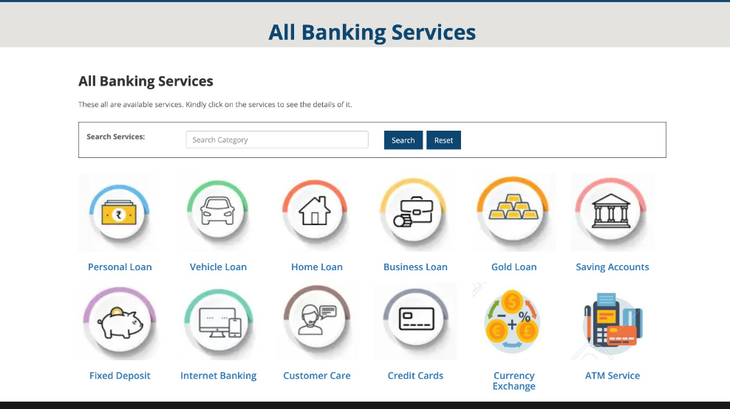

# 6. Conclusion

**Online banking has transformed the banking industry and significantly impacted customer-bank relationships. It offers advantages such as bill payments, account balance checks, and convenience. However, it also presents challenges, including security issues, fake emails, hacking, and fraud. To mitigate these risks, banks must prioritize security software-based systems, and customers should regularly update their passwords for added protection.**

**From the survey responses, it is evident that:**

* **Customer Point of View: Customers are generally satisfied with online banking due to its time-saving nature and convenience. They appreciate the ability to perform various activities, including bill payments and money transfers, without visiting physical bank branches.**
* **Bankers Point of View: Banks like SBI are committed to providing quality online banking services. Although they encounter occasional security and technical challenges, they are dedicated to continuous improvement. SBI's focus on customer service, offering a 4% interest rate on savings accounts, has resulted in increased customer trust and savings.**

**Recommendations**

* **Enhanced Security Measures: Banks should continually invest in improving their online security infrastructure to protect customers from cyber threats.**
* **User Education: Encourage customers to regularly update their passwords and educate them on safe online banking practices.**
* **Technical Improvements: Banks should prioritize addressing technical issues promptly to ensure a seamless online banking experience for customers.**
* **Customer-Centric Approach: Continue to prioritize customer service and offer competitive interest rates to maintain and expand customer trust.**

**By implementing these recommendations, banks can further enhance the online banking experience and strengthen customer trust in their services.**